Library Management System

Project Report

Beyza Dilem Yıldırım

2021

Table Of Contents

1 Introduction 3

1.1 Purpose 3

2 Need Analysis of the System 3

3 Concept Structure Design 3

3.1 Administrator Flow Chart 4

3.2 Main Data Definition 4

3.2.1 Administator Information 4

3.2.2 Books Information 5

4 Logic Structure Design 5

5 Database Diagram 6

6 Requirements to build the system 7

7 What is MySQL 7

8 What is XAMPP 8

9 Project Details 8

9.1 Login Panel Details 10

9.1.1 Panel Design 10

9.1.2 Codes 11

9.2 Main Panel Details 12

9.2.1 Panel Design 13

9.2.2 Codes 13

9.3 Book Information Panel Details 14

9.3.1 Panel Design 14

9.3.2 Codes 15

9.4 Admin Information Panel Details 20

9.4.1 Panel Design 20

9.4.2 Codes 21

10 References 25

Table Of Figures

Figure 1. Use Case Diagram 3

Figure 2. Administrator Flow Chart 4

Figure 3. Administrator Information Entity E-R Diagram 4

Figure 4. Books Information Entity E-R Diagram 5

Figure 5. MySQL Connection 8

Figure 6. XAMPP Activation 9

Figure 7. Database Structure 9

Figure 8. Book Table Structure 9

Figure 9. Login Table Structure 10

Figure 10. Login Panel Design 10

Figure 11. Login Button Codes 11

Figure 12. Clear Button Code 12

Figure 13. Close Button Code 12

Figure 14. Show Password Radio Button Code 12

Figure 15. Main Panel Design 13

Figure 16. Add/Delete Book Button Code 13

Figure 17. Add/Delete Admin Button Code 13

Figure 18. Log Out Button Code 14

Figure 19. Book Information Panel Design 14

Figure 20. Book Information Connection Code 15

Figure 21. Book Information Load Code 16

Figure 22. Book Information Tabke Mouseclicked Code 17

Figure 23. Add Button Codes 17

Figure 24. Edit Button Code 18

Figure 25. Delete Button Code 19

Figure 26. Cancel Button Code 19

Figure 27. Close Button Code 20

Figure 28. Admin Information Panel Design 20

Figure 29. Admin Information Connection Code 21

Figure 30. Admin Information Load Code 21

Figure 31. Admin Information Table Code 22

Figure 32. Add Button 22

Figure 33. Delete Button 23

Figure 34. Cancel Button 24

Figure 35. Close Button 24

Table Of Tables

Table 1. Book Information Database Diagram 6

Table 2. Sample Book Table 6

Table 3. Database Diagram 7

Table 4. Sample Login Table 7

# Introduction

The library plays an important role in the today's world. The management of the library books information by using computer could reduce manual management mistakes and enhance the efficiency of book management greatly. Therefore, using computer to manage library books information has very important significance.

## Purpose

This system helps the system to keep book records. Admin can add different books and then delete them, view book details in the library. Administrator must login before adding or removing books.

# Need Analysis of the System

Administrators have the following functions:

1. Password verification Login: only the correct account and password can be entered into the admin interface. If you enter the wrong username or password, the system displays an error and you cannot enter the system interface.
2. Add, Edit or delete a book: Upon successful login, the administrator can enter basic information of the book to add a new book, delete or edit a book in the book system.
3. Add, delete amin: The administrator can add or delete new admins and view other admin information.Then new admins can login the system.

# Concept Structure Design

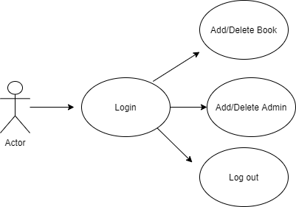

Figure 1. Use Case Diagram

## Administrator Flow Chart

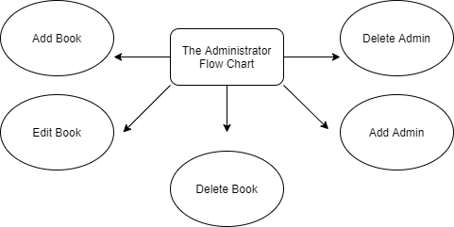

Figure 2. Administrator Flow Chart

## Main Data Definition

### Administator Information

Through analyzing the function of the library management system,we could draw a conclusion that was an entity of a system mainly includes admin information.

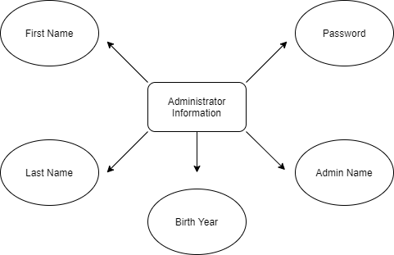

Figure 3. Administrator Information Entity E-R Diagram

### Books Information

Through analyzing the function of the library management system,we could draw a conclusion that was an entity of a system mainly includes books information.

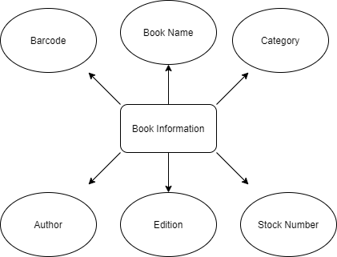

Figure 4. Books Information Entity E-R Diagram

Description: the book information entity mainly records the basic information of a book to get data to meet the needs of management.

# Logic Structure Design

Basic definitions of administrator entities and attributes: Administrator (first name, last name, birth year, admin name, password).

The basic definition of book entity and attribute: books (barcode, book name, category, author, edition, stock number,.)

# Database Diagram

|  |
| --- |
| book |
| barcode: int, unique |
| bookname: string |
| category: string |
| author: string |
| edition: int |
| stocknumber: int |

Table 1. Book Information Database Diagram

|  |  |  |  |  |  |
| --- | --- | --- | --- | --- | --- |
| Barcode | Book Name | Category | Author | Edition | Stock Number |
| 1111111 | Programming Pearls | Programming | Jon Bentley | 2 | 4 |
| 2222222 | The Buddha in the Attic | Novel | Julie Otsuka | 1 | 3 |
| 3333333 | Coders at Work | Programming | Peter Seibal | 1 | 1 |
| 4444444 | Animal Farm | Novel | George Orwell | 1 | 2 |

Table 2. Sample Book Table

|  |
| --- |
| login |
| firstname: string |
| lastname: string |
| birthyear: int |
| adminname: string, unique |
| password: string |

Table 3. Database Diagram

|  |  |  |  |  |
| --- | --- | --- | --- | --- |
| First Name | Last Name | Birth Year | Admin Name | Password |
| Joey | Smith | 1993 | joey | 12345 |
| Emily | White | 1999 | emily | emily |
| Jack | Wilson | 1988 | jack | 2345 |
| Thomas | Lee | 1973 | thomas | t123 |

Table 4. Sample Login Table

# Requirements to build the system

1. A java IDE like Apache netbeans.
2. Mysql connector for java
3. XAMPP

# What is MySQL

MySQL is a relational database management system based on SQL – Structured Query Language. The application is used for a wide range of purposes, including data warehousing, e-commerce, and logging applications.

The most common use for mySQL however, is for the purpose of a web database. It can be used to store anything from a single record of information to an entire inventory of available products for an online store.

In association with a scripting language such as PHP or Perl (both offered on our hosting accounts) it is possible to create websites which will interact in real-time with a mySQL database to rapidly display categorised and searchable information to a website user. (1)

# What is XAMPP

XAMPP is an abbreviation for cross-platform, Apache, MySQL, PHP and Perl, and it allows you to build WordPress site offline, on a local web server on your computer. This simple and lightweight solution works on Windows, Linux, and Mac – hence the “cross-platform” part.

Since WordPress isn’t a stand-alone application, XAMPP provides two essential components for its installation – Apache, which is used to create the local server, and MySQL which you can use as a database for your website. (2)

# Project Details

First, Apache Netbeans, mysql connector and xampp must be installed.

Then mysql connector must be connected to the used IDE. To connect to mysql, right click on dependencies and click on add dependency. (Figure 5.)

metin içeren bir resim

Açıklama otomatik olarak oluşturuldu

Figure 5. MySQL Connection

Apache and mysql must be activated from the downloaded xampp control panel. (Figure 6.)

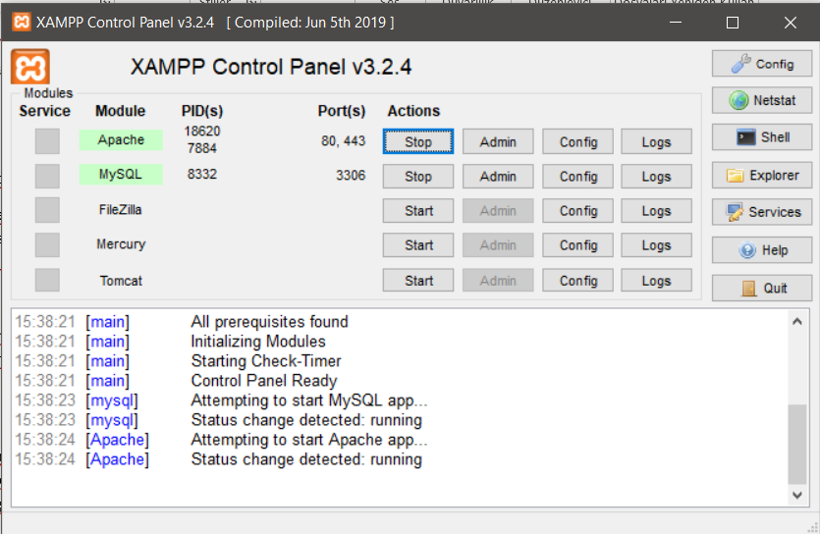

Figure 6. XAMPP Activation

After the installation is complete, project design and code writing can be started.

You should start by creating a jframe form in the project folder. Afterwards, the project can be designed from the design part.

After the design is completed, database and tables to be used should be created in xampp. (Figure 7., Figure 8., Figure 9.)

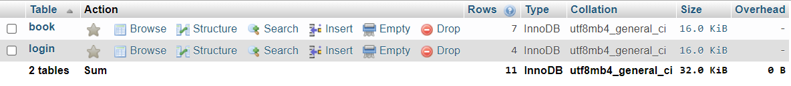

Figure 7. Database Structure

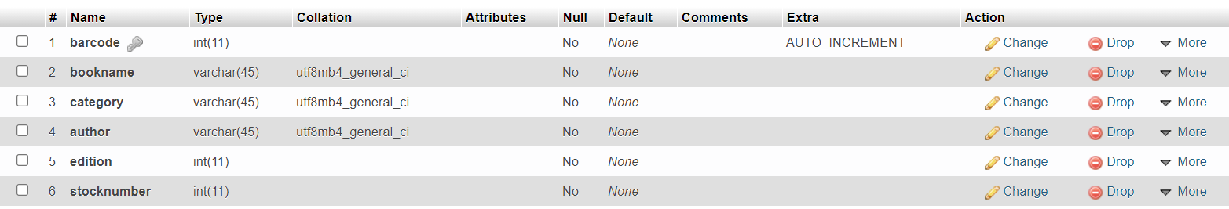

Figure 8. Book Table Structure

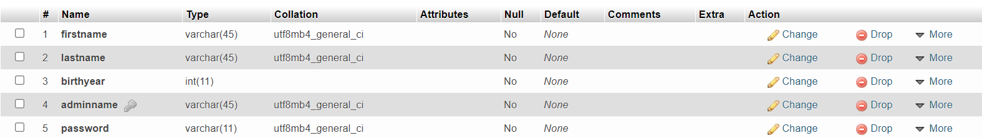

Figure 9. Login Table Structure

After the database and tables are created, the codes of the system can be written from the source part.

This project consists of 4 panels:

1. Login Panel
2. Main Panel
3. Book Information Panel
4. Admin Information Panel

## Login Panel Details

The login panel allows the admin to log in by entering their adminname and password.

### Panel Design

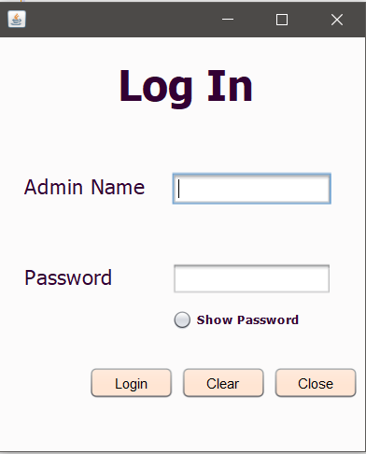

Figure 10. Login Panel Design

### Codes

#### Login Button

The login button allows to log into the system.

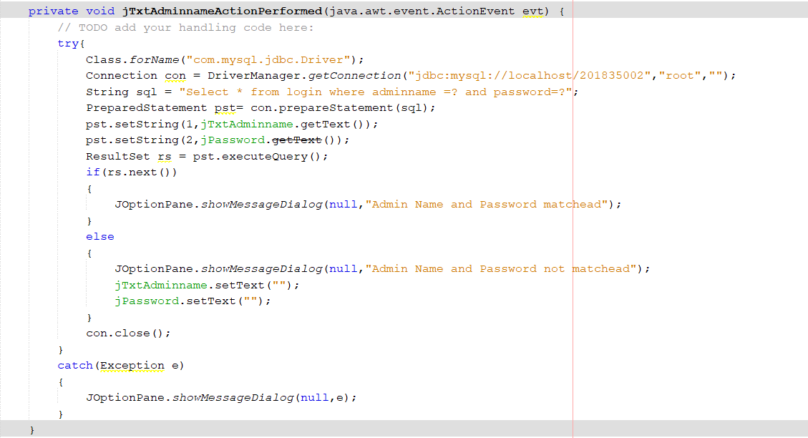

Figure 11. Login Button Codes

In order to save the adminname and password to the database, you must first connect to the created mysql database. Then, it is necessary to connect to the table containing the admin information with the select command. (Figure 9.)

PreparedStatement() object can then be used to efficiently execute sql statement multiple times.

The setString() and getText() methods are used to assign values to parameters.

ResultSet () is used to get the result of sql from database.

JOptionPane.showMessageDialog() is used to show message dialog.

If the login is successful, the system displays the message dialog "Administrator name and password matched". And the main panel opens.

If the login is not successful, it displays the "Admin name and password do not matched" message dialog. And you should try to login again.

#### Clear Button

The clear button resets the TextFields.

metin içeren bir resim

Açıklama otomatik olarak oluşturuldu

Figure 12. Clear Button Code

#### Close Button

This button close the system.

metin içeren bir resim

Açıklama otomatik olarak oluşturuldu

Figure 13. Close Button Code

#### Show Password Radio Button

This button makes the hidden password visible.

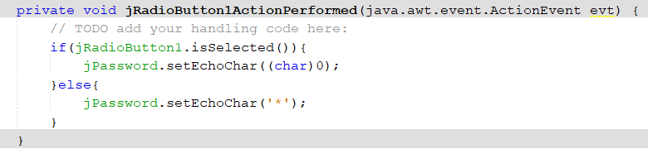

Figure 14. Show Password Radio Button Code

## Main Panel Details

There are 3 buttons in the main panel that are used to visit the library management system panel or admin information panel or to log out.

### Panel Design

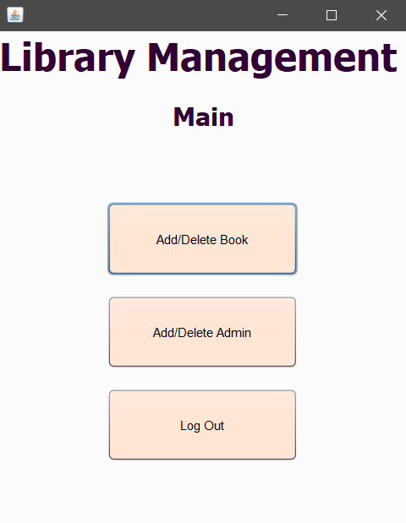

Figure 15. Main Panel Design

### Codes

#### Add/Delete Book Button

When clicked, it visits the book information panel.

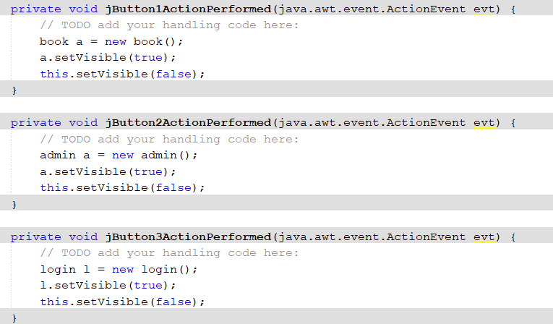

Figure 16. Add/Delete Book Button Code

#### Add/Delete Admin Button

When clicked, it visits the admin information panel.



Figure 17. Add/Delete Admin Button Code

#### Log Out Button

When clicked, it exits the system.



Figure 18. Log Out Button Code

## Book Information Panel Details

In this panel, the admin can enter basic information of the book to add a new book, delete or edit a book in the system.

### Panel Design

tablo içeren bir resim

Açıklama otomatik olarak oluşturuldu

Figure 19. Book Information Panel Design

### Codes

In the source part, first in order to connect to the database created, the codes in Figure 20. must be written.

metin içeren bir resim

Açıklama otomatik olarak oluşturuldu

Figure 20. Book Information Connection Code

In order to transfer the data in the database to the table in the panel, the codes in Figure 21. should be written.

metin içeren bir resim

Açıklama otomatik olarak oluşturuldu

Figure 21. Book Information Load Code

ResultSet () is used to get the result of sql from database.

ResultSetMetaData() is an object that can be used to get information about the types and properties of the columns in a ResultSet object.

getColumnCount() method gets the number of columns in a row.

DefaultTableModel() is an implementation of TableModel that uses a Vector of Vectors to store the cell value objects.

setRowCount() sets the number of rows in the model. If the new size is greater than the current size, new rows are added to the end of the model. If the new size is less than the current size, all rows at index rowCount and greater are discarded.

The setString() and getText() methods are used to assign values to parameters.

When a row of the table is clicked, the system displays the information in that row. This way, books can be edited or deleted.(Figure 22.)

metin içeren bir resim

Açıklama otomatik olarak oluşturuldu

Figure 22. Book Information Tabke Mouseclicked Code

#### Add Button

When the add button is clicked, the information entered by the admin is added to the book table (Figure 8.) in the database with the insert statement.

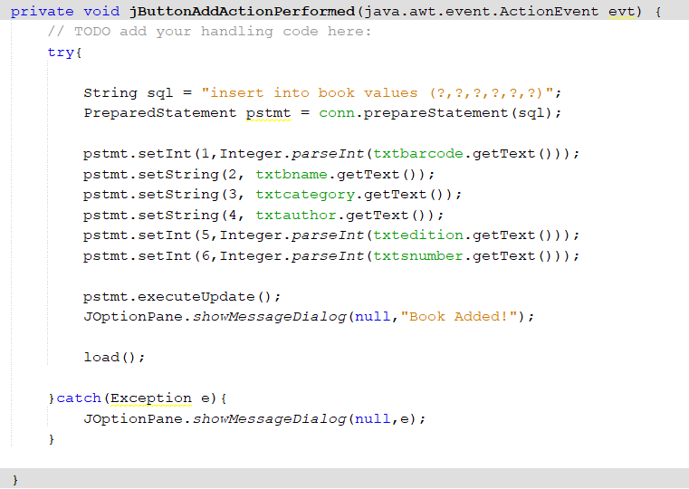

Figure 23. Add Button Codes

Insert statement is used to add information to the database.

When the book is added, 'Book Added!' message dialog is displayed.

#### Edit Button

The edit button is used to change the information of a book added to the list. When you click on a row in the list, the information on that row appears in TextFields. Thus, the information can be changed.

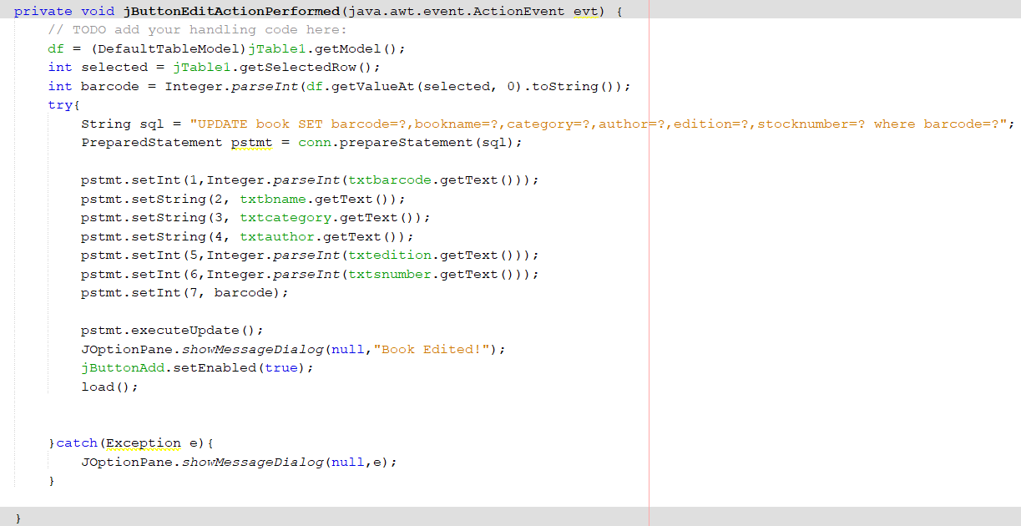

Figure 24. Edit Button Code

Update statement is used to update information from the database (book table).

When the book is edited, 'Book Edited!' message dialog is displayed.

#### Delete Button

By selecting a row and clicking the delete button, the selected information is deleted from the database.

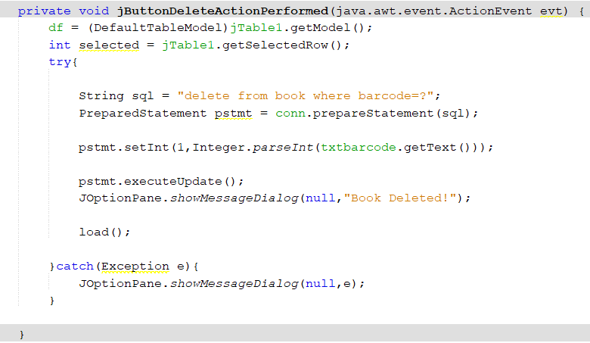

Figure 25. Delete Button Code

Delete statement is used to delete information from the database (book table).

When the book is deleted, 'Book Deleted!' message dialog is displayed.

#### Cancel Button

The cancel button resets the TextFields and selected rows in the table.

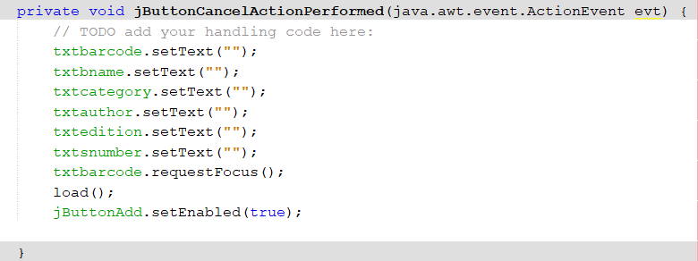

Figure 26. Cancel Button Code

#### Close Button

This button close the panel and visits main panel.

metin içeren bir resim

Açıklama otomatik olarak oluşturuldu

Figure 27. Close Button Code

## Admin Information Panel Details

The admin information panel is used to add or delete admin. The newly added admin gains access to the system.

### Panel Design

tablo içeren bir resim

Açıklama otomatik olarak oluşturuldu

Figure 28. Admin Information Panel Design

### Codes

The connect (Figure 29.) and load (Figure 30.) codes should be written as in the book information panel.

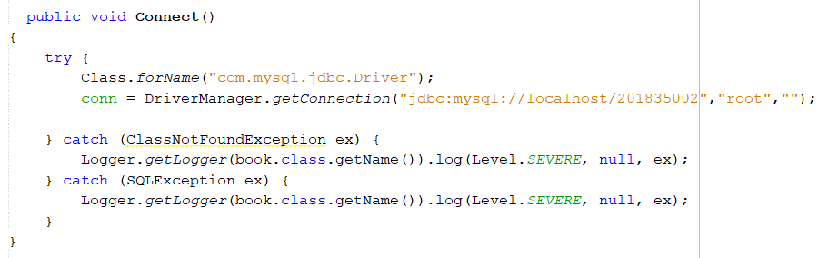

Figure 29. Admin Information Connection Code

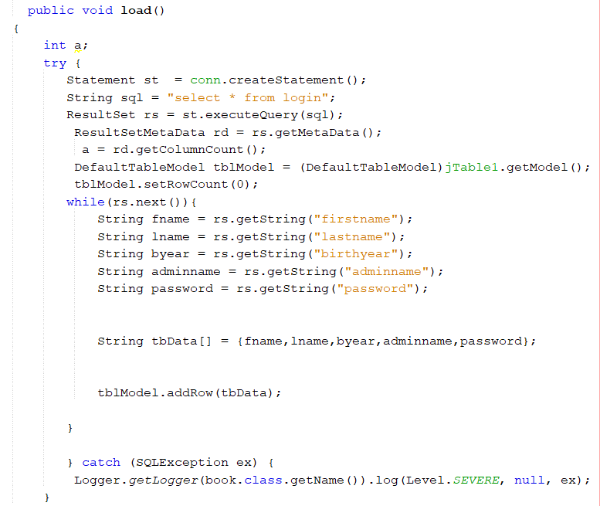

Figure 30. Admin Information Load Code

When a row of the table is clicked, the system displays the information in that row. This way, admins can be deleted.(Figure 31.)

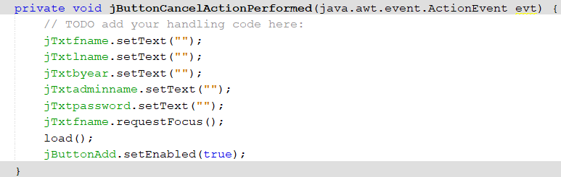

Figure 31. Admin Information Table Code

#### Add Button

When the add button is clicked, the information entered by the admin is added to the login table (Figure 9.) in the database with the insert statement.

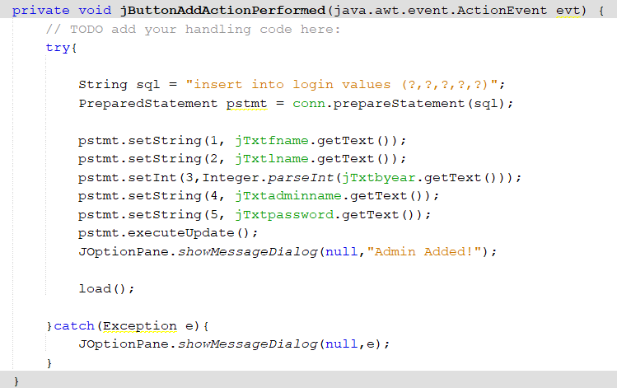

Figure 32. Add Button

Insert statement is used to add information from the database.

When the admin is added, 'Admin Added!' message dialog is displayed.

#### Delete Button

By selecting a row and clicking the delete button, the selected information is deleted from the database.

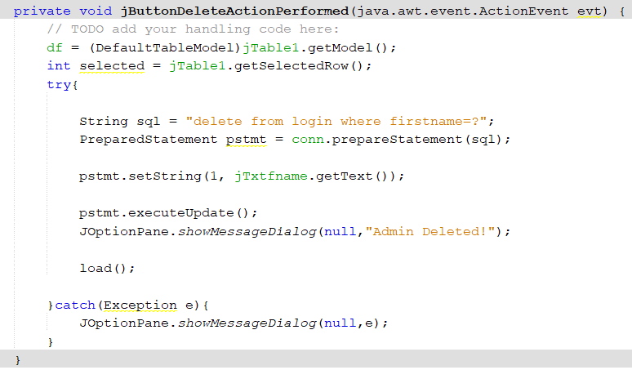

Figure 33. Delete Button

Delete statement is used to delete information from the database (login table).

When the admin is deleted, 'Admin Deleted!' message dialog is displayed.

#### Cancel Button

This button resets the TextFields and selected rows in the table.

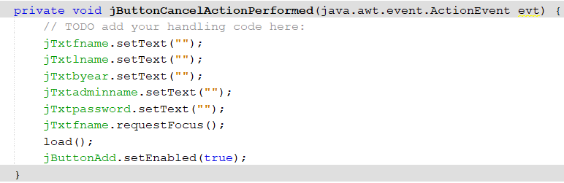

Figure 34. Cancel Button

#### Close Button

The Close button close the panel and visits main panel.

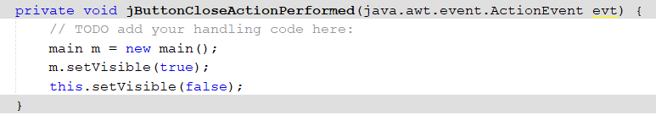

Figure 35. Close Button

# References

1. **What is mySQL and why do I need it? *123 Reg.* [Çevrimiçi] https://www.123-reg.co.uk/support/servers/what-is-mysql-and-why-do-i-need-it/.**

**2. XAMPP Tutorial: How to use XAMPP to set up WordPress on localhost. *undsgn.* [Çevrimiçi] https://undsgn.com/xampp-tutorial/.**